|  |
| --- |
| **CS 4613** |
| Sudoku Project  Santino Ricatto  Spring 2019 |

Contents

Table of Contents

How to compile 2

How to run 3

The source code 4

Sugar.h 4

Sugar.cpp 5

main.cpp 9

backTrack algorithm implementation 24

Main function 26

# How to compile

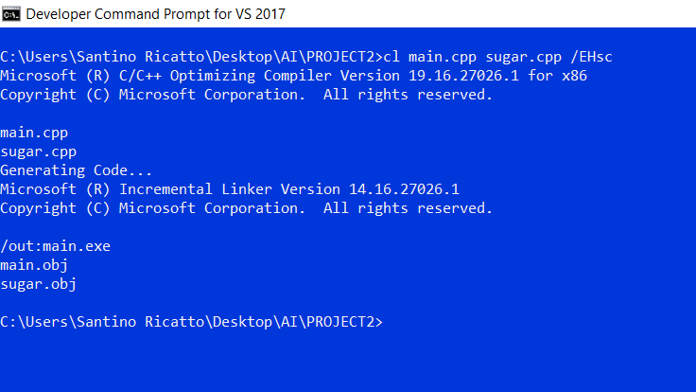  
Simply use the command “cl main.cpp sugar.cpp /EHsc”  
in the developer command prompt in Windows.  
Note: Code may not compile on other systems, I have only tested windows.  
The output should be main.exe  
See below:

# How to run

Main.exe is a command line utility.  
Usage:  
 main.exe <input filename> <output filename>  
If no output file is specified, the output will be printed to the screen  
If it can’t find a file, it’ll say so.  
If it is given an unsolvable puzzle, it’ll say so.  
See below:  
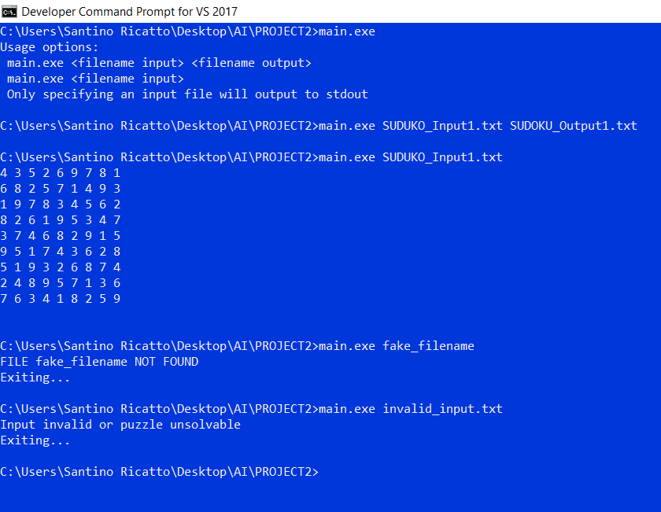

# The source code

## Sugar.h

#ifndef tyuityuityuityuityuifghjfghjfghjvbnvbnmvnbm

#define tyuityuityuityuityuifghjfghjfghjvbnvbnmvnbm

//these #define are what I used to iterate over the neighbor set or domain set of a num

#define decode(a) decoder decodername(a);for(int i=decodername.first();i!=-1;i=decodername.next())

#define neighborSet(a) allNeighbors decodername(a);for(int i=decodername.first();i!=-1;i=decodername.next())

Info

The #define statements defining decode(a) and neighborSet(a)   
correspond to the classes defined below.

These are essentially iterators.  
  
To store the values of allNeighbors  
for  
neighborSet(a)  
I used a linked list  
that I called HSHLL  
  
The text in orange prevents the compiler from accessing this file more than once.

class decoder{

int domain;

public:

decoder(int in);

int first();

int next();

};

struct HSHLL{

int mine;

HSHLL* next;

};

class HashLL{

HSHLL* first;

public:

HashLL();

void push(int neue);

bool exists();

int pop();

};

class allNeighbors{

HashLL neighbors;

public:

allNeighbors(int in);

int first();

int next();

};

#endif

## Sugar.cpp

//This is a syntactical sugar thing

Sugar.cpp

The first par of sugar.cpp is the implementation of the decoder.  
  
The decoder outputs the domain of a num in an iterable fashion.

It gets the domain as a binary item in the form of an int.

decoder::first()  
and  
decoder::next()  
remove one item from the domain and return it.

//to make code more legible

#include "sugar.h"

#include <iostream>

#include <string>

#include <vector>

#include <fstream>

decoder::decoder(int in){domain=in;}

//decoder will output items from the domain in an iterable fasion.

//not implemented with the standardized iterable.

int decoder::first(){

return this->next();

}

int decoder::next(){

if (domain==0)

return -1;

for (int i = 0; i<9; i++){

if (domain & (1<<i)){ //if i'th bit exists (starts at 1 goes to 256 aka 9)

domain = domain ^ (1<<i);//remove a bit

return i+1; //return that i existed

}

}

return -1;

}

//Code for an int linked list stolen from my project 1 code.

//We're generating the neighbors every time we access. Might make more optimal later.

HashLL::HashLL(){

first = new HSHLL();

Sugar.cpp

This next part of sugar.cpp is the implementation of a linked list that the allNeighbors class uses to generate output for the neighborSet(a) iterator.

This code is adapted from part of my project 1 code and as such it has a weird name.

The implementation for allNeighbors is below.

first->mine = -1;

first->next = NULL;

}

void HashLL::push(int neue){

HSHLL* guy = new HSHLL;

guy->mine = neue;

guy->next = first;

first = guy;

return;

}

bool HashLL::exists(){

return first!= NULL;

}

int HashLL::pop(){

HSHLL* guy = first;

int ret = first->mine;

first = first->next;

delete guy;

return ret;

}

allNeighbors::allNeighbors(int in){

Sugar.cpp

An allNeighbors instance outputs the neighbor locations of a num in an iterable fashion.

It gets the location of the num as an int.

Verticals:  
in % 9 gets the bottom  
adding 9 gets the item on top of that.

Horizontals:  
adds 9 to 0  
until it is larger than in  
then adds one 9 times

3X3:  
This gets the four items that the vertical and horizontal missed.

:

//from "in" generate all neighbors push into HashLL

neighbors = HashLL();

//Verticals

for(int i=0;i<9;i++)

neighbors.push( (in%9)+(i*9) );

//Horizontals

int ndexs[]={80,71,62,53,44,35,26,17, 8};

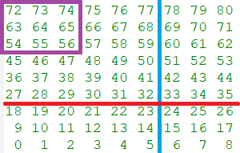 int k;

for(k=0;k<9;k++)

if(in<=ndexs[8-k])

goto there;

there:;;

for(int i=0;i<9;i++)

neighbors.push( ndexs[8-k] - i );

// 3x3 excludes duplicates.

int b,n,m,f,j;

k=ndexs[8-k]-8;

for(b=0;b<9;b++)

if ((9*b)==k)

break;

if(b%3==0){

f=9;j=18;

}

else if(b%3==1){

f=9;j=-9;

}

else if(b%3==2){

f=-9;j=-18;

}

if(in%3==0){

n=in+1;m=in+2;

Sugar.cpp

The top is the tail end of   
allNeighbors::allNeighbors(int in)

The bottom functions make the class iterable.

}

else if(in%3==1){

n=in+1;m=in-1;

}

else if(in%3==2){

n=in-1;m=in-2;

}

neighbors.push(n+f);

neighbors.push(m+f);

neighbors.push(n+j);

neighbors.push(m+j);

} //End of allNeighbors init

int allNeighbors::first(){

return this->next();

}

int allNeighbors::next(){

if (neighbors.exists())

return neighbors.pop();

return -1;

}

## main.cpp

#include <iostream>

#include <string>

#include <vector>

#include <fstream>

#include <bitset>

#include "sugar.h"

using namespace std;

main.cpp

This is the top of main.cpp

Gives a tl;dr of sugar.h

// Everything above this line is global constants and includes

/*

Sugar.h info:

Adds the decode(int) loop

essentially decodes a num

into ints accessable by the

name i, an int.

*/

class num{

unsigned int self;

Main.cpp  
Class num

Each item in the state is a num

From here down only important notes are made.

Important comments will be highlighted green.

// A bitwise representation of a number.

//bits [31-19] Unused

//bits [9-17] Domain Set 1-9

//bits [0-8] Number 1-9

public:

num(){

self = 0b111111111000000000; //init with domain 123456789

}

num(int neue){

self = ((neue==0)?0b111111111000000000:(1 << neue-1));

}

num(int old, bool spec){

self = old;

}

int getNum() const {

//Returns a numerical representation of num

//If domain only or failure returns 0;

if (self == 0)return 0;

if (self > 256)return 0;

if (self<=256){

for(int i =0;i<9;i++){

if ( (self & (1<<i) ) != 0 )

return i+1;

}

}

return -90210;

}

void setNum(int neue){

self = ((neue==0)?0b111111111000000000:(1 << neue-1));

}

unsigned int getInt() const {return self;} //Returns the unmodified "self"

num& becomeDomain(){ // shift Domain to Final

self = self >> 9;

return *this;

}

bool isComplete()const{

return ( (self<512) && (self > 0) ); //returns if a num has a final value

}

num& operator-= (const num& rhs){//Removes a number to the Domain set bits [9-17]

int neue = rhs.getNum();

this->removeFromDomain(neue);

return *this;

}

int countRemainingDomain()const{ //counts how many things in domain

if (this->isComplete())

return 0;

int count=0;

decode(self>>9){ //decode iterates for each domain item.

count++;

}

return count;

}

void removeFromDomain(int the){ //removes item from domain

if( self & (1<<(the+9-1)))

self-=(1<<(the+9-1));

}

int nextPossibleDomain(){ //removes an item from domain and returns it

decode(self>>9){

this->removeFromDomain(i);//remove the first and

return i;//dont continue loop.

}

return -1;

}

};

ostream& operator<<(ostream& os, const num& n){ //Allows us to pump num instances into file or stdout

os<<n.getNum();

return os;

}

/*

class num info:

a num is a representation of a

single spot in the 9x9 grid

the low 18 bits represent the Domain and Final

Unused:[31-18] Domain:[17-9] Final Setting:[8-0]

bits in the domain and final work like this:

987654321 and 9876543231 respectively

so if a domain looks like 010000100

then the domain is 8 and 3.

*/

struct state{

State

State is the problem definition, it also acts as the problem state.  
  
It stores 81 num::num()s  
in a linear array that represents the sudoku board.

Shown here is the default constructor and the deep copy constructor

num* layout;

state(){

layout = new num[81] ;

}

state(state* old){

layout = new num[81];

for(int i=0;i<81;i++){

layout[i] = num(old->layout[i].getInt(), true);

}

}

//State::doForwardChecking(int)  
Takes a location and updates the domains of all the neighbors of that location.

void doForwardChecking(int changedValueLocation){

neighborSet(changedValueLocation){

if (!(layout[i].isComplete() )){ //for all neighbors if dont have final value, update domain layout[i].removeFromDomain( layout[changedValueLocation].getNum() );

}

}

}

void globalForwardChecking(){//for all values if completed (has a final value) do forward checking for his neighbors

for(int l=0;l<81;l++){

if (layout[l].isComplete()){

this->doForwardChecking(l);

}

}

}

bool checkValidityOfDomainItem(int loc, int domItem)const{ //Returns if a domain value is valid in the current context. This is not needed but it parallels the slide code

neighborSet(loc){

if(layout[i].getNum() == domItem && i!=loc){

return false; //If a value at any neighbor location of loc is domItem, ret false

}

}

return true;

}

num* selectUnassignedVariable()const{ //Using the heuristic gets an unassigned num

return this->minimumRemainingValueWithDegreeHeuristic();

}

int getDegreeAtLoc(int loc)const{ //returns the number of unassigned neighbors, the “degree” of a num in the context of the problem

int count=0;

neighborSet(loc){ //a loop where i is loc of each neighbor

if (!(layout[i].isComplete())){

count++;

}

}

return count;

}

int getLocationOf(num* teh)const{ //finds the location as a memory offset from &layout[0]

for(int row=72;row>=0;row-=9){

for(int col=0;col<9;col++){

if( &layout[row+col] == teh)

return (row+col);

}

}

return -1;

}

num* minimumRemainingValueWithDegreeHeuristic()const{

Main.cpp  
state

Minimum Remaining Value With Degree Heuristic

This is the same as the ORDER-DOMAIN-VALUES function seen on the slides.

The primary difference is that this struct uses forward checking as its INFERENCE  
and is therefore not “dynamic”  
So instead of sorting and keeping a list, I searched for what the first thing on the INFERENCES list would have been.  
  
goalTest checks every possible point of failure and returns if layout is in a goal state.  
  
Technically these run in constant time lol. The code can be wasteful because even the hardest puzzle can be solved in less than 10 seconds.

num* a = layout;

for(int l=0;l<81;l++){

if (!(layout[l].isComplete())){a = &layout[l];break;} // Force a to be an incomplete value

}

for(int l=0;l<81;l++){

if (!(layout[l].isComplete())){

if (layout[l].countRemainingDomain() < a->countRemainingDomain()) //If mrv l < mrv a ; a = l

a = &layout[l];

else if (layout[l].countRemainingDomain() == a->countRemainingDomain()) //if equal

if (this->getDegreeAtLoc(l) > this->getDegreeAtLoc( this->getLocationOf(a) ) )// and degree l > degree a

a = &layout[l];

}

}

return a;

}

bool goalTest()const{

for(int l=0;l<81;l++){

if (!(layout[l].isComplete())){//if l'th item not complete

return false;

}

neighborSet(l){//check correctness (if bad input this'll catch it)

if ((layout[l].getNum() == layout[i].getNum()) && (i != l)){

return false;

}

}

}

return true;

}

void removeFromMemory(){ //Frees memory allocated for the state

delete layout;

return;

}

state* backTrack(); //Backtrack is declared here and defined just above the main function

};

/*

state struct info:

This is the problem definition

*/

ostream& operator<<(ostream&os , const state& st){ //Allows us to chuck a state into a file or stdout

for(int row=72;row>=0;row-=9){

for(int col=0;col<9;col++){

os<<st.layout[row+col]<<" ";

}

os<<"\n";

}

return os;

}

Main.cpp  
Filehandler

This function is the start of the filehandler code. This function allows us to quickly sanitize the input from the file.   
  
Invalid input like letters and whitespace and stuff will become a negative one rendering the puzzle unsolvable.

int convertChar(char a){

if (a=='0'){

return 0;

}

else if (a=='1'){

return 1;

}

else if (a=='2'){

return 2;

}

else if (a=='3'){

return 3;

}

else if (a=='4'){

return 4;

}

else if (a=='5'){

return 5;

}

else if (a=='6'){

return 6;

}

else if (a=='7'){

return 7;

}

else if (a=='8'){

return 8;

}

else if (a=='9'){

return 9;

}

return -1;

}

Main.cpp  
Filehandler

The filehandler class only handles getting a state from a text file.

If it is passed a filename of a file that does not exist, it’ll cry and exit.

class FileHandler{ //A file handler for problems

string filename;

state * st;

public:

FileHandler(string fileName, state* a){

st = a;

filename = fileName;

ifstream file;

string temp="";

file.open(fileName);

if (file.is_open()){

for(int row=72;row>=0;row-=9){

getline(file,temp);

for(int col=0;col<9;col++){

a->layout[row+col] = num(convertChar(temp[col*2]));

//The number at place in file

}

}

file.close();

}

else{

cerr << "FILE "<< fileName <<" NOT FOUND"<<endl<<"Exiting..."<<endl;

exit(5);

}

a->globalForwardChecking();

}

};

void unitTests(){

//This is how I tested every possible issue.

//Ignore this.

int failures = 0;

num* J;

num* L = new num();

cout<<"Starting tests\n";

Main.cpp  
Unit tests

The unit test code has been highlighted in light green.  
  
It is how I tested the implementation of the num and state.  
  
Features have been exhaustively tested.  
  
This is just what was left in the unit testing code when development was done.

It should not be relevant to grading though it has been left in for completeness.

for(int i=1;i<10;++i){

cout<<"Testing with final: "<<i<<"\n";

J = new num(i);

cout<<"\tgetNum: "<<J->getNum()<<" should be: "<<i<<endl;

if(J->getNum() != i) failures++;

cout<<"\tgetInt: "<<J->getInt()<<" should be: "<<(1<<i-1)<<endl;

if(J->getInt() != (1<<i-1)) failures++;

cout<<"\tisComplete: "<<J->isComplete()<<" should be: "<< true <<endl;

if(J->isComplete() != true) failures++;

cout<<"\tcountRemainingDomain: "<<J->countRemainingDomain()<<" should be: "<<0<<endl;

if(J->countRemainingDomain() != 0 ) failures++;

cout<<"\tnextPossibleDomain: "<<J->nextPossibleDomain()<<" should be: "<<-1<<endl;

if(J->nextPossibleDomain() != -1) failures++;

cout<<"END\n\n";

delete J;

}

cout<<"Testing with Domainset: FULL\n";

cout<<"\tgetNum: "<<L->getNum()<<" should be: "<<0<<endl;

if(L->getNum() != 0) failures++;

cout<<"\tgetInt: "<<L->getInt()<<" should be: "<<(0b111111111<<9)<<endl;

if(L->getInt() != (0b111111111<<9)) failures++;

cout<<"\tisComplete: "<<L->isComplete()<<" should be: "<< false <<endl;

if(L->isComplete() != false)failures++;

cout<<endl;

cout<<"\tcountRemainingDomain: "<<L->countRemainingDomain()<<" should be: "<<9<<endl;

if(L->countRemainingDomain() != 9)failures++;

cout<<"\tnextPossibleDomain: "<<L->nextPossibleDomain()<<" should be: "<<1<<endl;

cout<<"\tnextPossibleDomain: "<<L->nextPossibleDomain()<<" should be: "<<2<<endl;

*L -= num(3);

cout<<"\tINFO removed 3 from domain with -=\n";

cout<<endl;

cout<<"\tnextPossibleDomain: "<<L->nextPossibleDomain()<<" should be: "<<4<<endl;

cout<<"\tcountRemainingDomain: "<<L->countRemainingDomain()<<" should be: "<<(9-4)<<endl;

cout<<endl;

cout<<"\tnextPossibleDomain: "<<L->nextPossibleDomain()<<" should be: "<<5<<endl;

cout<<"\tnextPossibleDomain: "<<L->nextPossibleDomain()<<" should be: "<<6<<endl;

cout<<endl;

cout<<"\tnextPossibleDomain: "<<L->nextPossibleDomain()<<" should be: "<<7<<endl;

cout<<"\tnextPossibleDomain: "<<L->nextPossibleDomain()<<" should be: "<<8<<endl;

cout<<"\tcountRemainingDomain: "<<L->countRemainingDomain()<<" should be: "<<1<<endl;

failures+=(L->countRemainingDomain()-1);

L->becomeDomain();

cout<<"\tINFO did L->becomeDomain()\n";

cout<<endl;

cout<<"\tgetNum: "<<L->getNum()<<" should be: "<<9<<endl;

if(L->getNum() != 9)failures++;

cout<<"\tgetInt: "<<L->getInt()<<" should be: "<<(1<<8)<<endl;

if(L->getInt() != (1<<8))failures++;

cout<<endl;

cout<<"\tisComplete: "<<L->isComplete()<<" should be: "<< true <<endl;

if(!L->isComplete())failures++;

cout<<"\tcountRemainingDomain: "<<L->countRemainingDomain()<<" should be: "<<0<<endl;

if(L->countRemainingDomain()!=0)failures++;

cout<<"\tnextPossibleDomain: "<<L->nextPossibleDomain()<<" should be: "<<-1<<endl;

if(L->nextPossibleDomain()!=-1)failures++;

cout<<"END of domainSet FULL tests\n\n";

cout<<"The following assume an input text of SUDOKU_Input1.txt:\n0 0 0 2 6 0 7 0 1\n6 8 0 0 7 0 0 9 0\n1 9 0 0 0 4 5 0 0\n"

<<"8 2 0 1 0 0 0 4 0\n"

<<"0 0 4 6 0 2 9 0 0\n"

<<"0 5 0 0 0 3 0 2 8\n"

<<"0 4 0 0 5 0 0 3 6\n"

<<"7 0 3 0 1 8 0 0 0\n\n";

state theState;

FileHandler fh("SUDUKO_Input1.txt", &theState);

cout<<"Testing forward checking:\n\t";

cout<<(bitset<32>(theState.layout[37].getInt()))<<" Should be:\n\t";

cout<<(bitset<32>(0b111111111<<9))<<"\n\t";

neighborSet(37)

theState.doForwardChecking(i);

cout<<(bitset<32>(theState.layout[37].getInt()))<<" Should be:\n\t";

cout<<(bitset<32>(0b001000101<<9))<<"\n\n";

cout<<" MRVw/DH:"<<theState.minimumRemainingValueWithDegreeHeuristic()<<"\n";

unsigned int test;

cout<<"testing domain traversal and global forward checking. (pt1)\n";

theState.globalForwardChecking();

theState.globalForwardChecking();

theState.globalForwardChecking();

for(int l=0;l<81;l++){

test = theState.layout[l].getInt();

if(theState.layout[l].isComplete()){

decode(test>>9){

cout<<"Failure: \n\tdomain found: "<<i<<"\n";

failures++;

}

}

else{

test = theState.layout[l].countRemainingDomain();

neighborSet(l){

if(theState.layout[i].isComplete()){

theState.layout[l].removeFromDomain( theState.layout[i].getNum() );

}

}

if(theState.layout[l].countRemainingDomain() != test){

cout<<"Domain not updated properly at:"<<l<<"\n";

failures++;

}

}

}

cout<<"\t";

cout<<(bitset<32>(theState.layout[37].getInt()))<<" Should be:\n\t";

cout<<(bitset<32>(0b001000101<<9))<<"\n\n";

cout<<theState.layout[79].getInt()<<"\n\n";

cout<<theState<<endl;

cout<<"END\nTOTAL NUMBER OF FAILURES: "<<failures<<"\n";

}

//The only important part is that it’ll report how many software errors are detected if it is enabled   
(highlighted in blue)

Main.cpp  
state::  
backtrack()

The colors here are meant to correspond with the slide on the next page adapted from the one shown in class.

## backTrack algorithm implementation

state* state::backTrack(){

if (this->goalTest() == true)

return this;

state* result;

state* duplicate;

int location;

num* var = this->selectUnassignedVariable();

location = this->getLocationOf(var);

for(int domainItem = var->nextPossibleDomain(); domainItem != -1; domainItem = var->nextPossibleDomain() ){

if ( this->checkValidityOfDomainItem(location, domainItem) ){ //If domainItem consistent with assignment

duplicate = new state(this);

duplicate->layout[location].setNum(domainItem);

duplicate->doForwardChecking(location);

result = duplicate->backTrack();

if (result != NULL){

this->removeFromMemory(); //Will remove self from memory because goal state found and the recursive "I" am no longer needed

return result;

}

duplicate->removeFromMemory();//remove from assignment

}

}//nextPossibleDomain will remove the domain item from var

return NULL; //NULL is failure.

}

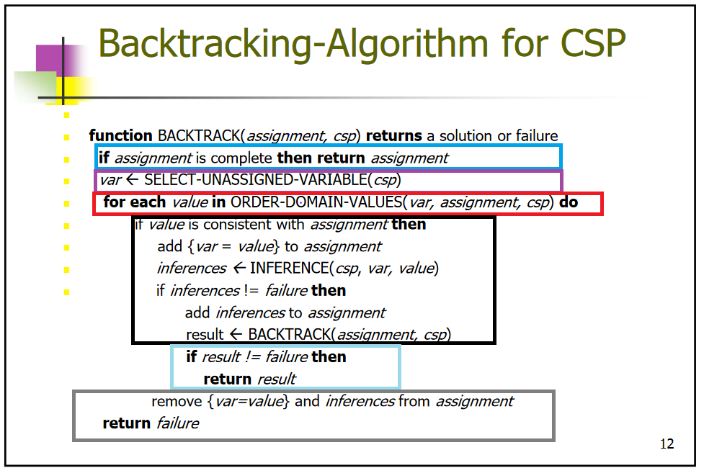

## Main function

int main(int argc, char *argv[]){

Main.cpp  
main function

If the program was called with too many or too few parameters, it’ll complain and exit.  
  
It makes an instance of state called theState  
which becomes the initial state from the input file  
and a state pointer to point at the goal state that will exist on the heap.

Calling backtrack on theState returns a pointer to the goal state on the heap… or NULL if there was no valid answer.

Then depending on user preference it will print or write to a file the answer.

if((argc == 1)||(argc > 3)){

cout<<"Usage options:\n main.exe <filename input> <filename output>"

<<"\n main.exe <filename input>\n Only specifying an input file will output to stdout\n";

exit(5);

}

state theState;

state* ans;

FileHandler fh(argv[1], &theState);

ans = theState.backTrack();

if(ans == NULL){

cout<<"Input invalid or puzzle unsolvable\nExiting...\n";

exit(0);

}

if(argc == 3){

ofstream Ofile;

Ofile.open(argv[2]);

Ofile<< *ans;

}

else{

cout<< *ans << endl;

}

exit(0);

}